BCSE497J - Project-I
GRAPHANCHOR: A LOCAL VECTOR-GRAPH STORAGE ENGINE WITH INCREMENTAL INGESTION AND HYBRID RETRIEVAL FOR OFFLINE RAG USING ON-DEVICE LANGUAGE MODELS
by
23BCE0594 | YAGANTI LOHITHNATH REDDY
23BCE0822 | SHAYLA TYAGI

Under the Supervision of
Dr. R. Sathyaraj
Professor Grade 1
School of Computer Science and Engineering

B.Tech.
in
Computer Science and Engineering

School of Computer Science and Engineering
September 2026
ABSTRACT
Standard Retrieval-Augmented Generation (RAG) systems retrieve document chunks using only embedding similarity, which performs poorly on queries requiring relational understanding, such as identifying exceptions, dependencies, or contradictions between pieces of information. Existing graph-based solutions, such as GraphRAG, address this limitation by constructing a relationship graph at ingestion time, but depend on large, expensive cloud-based language models and require reprocessing the entire document corpus whenever new content is added, making them costly and impractical for private, incrementally growing use cases.
This project, GraphAnchor, proposes a local, incrementally-growing storage engine that ingests documents one at a time. A small on-device language model extracts entity-relation triples from each chunk, which are stored as graph edges alongside vector embeddings in a single unified local database combining SQLite and ChromaDB. New documents are attached to the existing graph through lightweight entity matching with an embedding-similarity fallback, avoiding full-corpus reconstruction. At query time, retrieval is hybrid: vector similarity locates entry-point chunks, and a confidence-thresholded breadth-first graph traversal, up to four hops deep, expands outward to pull in structurally related chunks that similarity search alone would miss.
The system runs entirely offline using Ollama for local inference, FastAPI for the backend, and a lightweight web frontend for document upload and querying. The ingestion pipeline, dual-storage layer, hybrid multi-hop retrieval, and grounded answer generation have all been implemented and verified end-to-end; a formal evaluation comparing this hybrid approach against plain vector retrieval is in progress. The project aims to demonstrate improved retrieval accuracy on relational and multi-hop queries, reduced computational cost, and enhanced privacy compared to existing cloud-dependent graph-based RAG approaches.
Keywords - Retrieval-Augmented Generation, Knowledge Graph, On-Device Language Models, Vector Search, Local-First Systems.
TABLE OF CONTENTS
Sl.No | Contents | Page No.
 | Abstract | i
1. | INTRODUCTION | 1
 | 1.1 Background | 1
 | 1.2 Motivation | 1
 | 1.3 Scope of the Project | 2
2. | PROJECT DESCRIPTION AND GOALS | 3
 | 2.1 Literature Review | 3
 | 2.2 Research Gap | 4
 | 2.3 Objectives | 4
 | 2.4 Problem Statement | 5
 | 2.5 Project Plan | 5
3. | TECHNICAL SPECIFICATION | 6
 | 3.1 Requirements | 6
 | 3.1.1 Functional | 6
 | 3.1.2 Non-Functional | 6
 | 3.2 Feasibility Study | 7
 | 3.2.1 Technical Feasibility | 7
 | 3.2.2 Economic Feasibility | 7
 | 3.2.3 Social Feasibility | 7
 | 3.3 System Specification | 8
 | 3.3.1 Hardware Specification | 8
 | 3.3.2 Software Specification | 8
4. | DESIGN APPROACH AND DETAILS | 9
 | 4.1 System Architecture | 9
 | 4.2 Design | 10
 | 4.2.1 Data Flow Diagram | 10
 | 4.2.2 Use Case Diagram | 11
5. | REFERENCES | 12
1. INTRODUCTION
1.1 Background
The rapid growth of unstructured text data has made Retrieval-Augmented Generation (RAG) a standard approach for grounding large language model outputs in external, up-to-date information. Conventional RAG pipelines split documents into chunks, embed them, and retrieve the most similar chunks to a query using vector search. This works well when an answer can be found in a single, semantically similar passage, but performs poorly when an answer requires connecting information spread across multiple chunks through relationships such as dependencies, exceptions, or contradictions.
Graph-based RAG systems, most notably GraphRAG, address this by building an explicit relationship graph over the document corpus at ingestion time and using graph traversal alongside vector search during retrieval. However, these systems rely on large, cloud-hosted language models to extract entities and relationships, and they rebuild the graph from the full corpus whenever new documents are added. This makes them expensive, slow, and unsuitable for private or offline use cases where documents arrive incrementally and cannot be sent to a third-party service. This project examines whether a small, on-device language model can perform this graph-construction role locally and incrementally, without sacrificing the relational retrieval benefits of graph-based RAG.
1.2 Motivation
Most individuals and small organizations who want to build a personal or private knowledge base from their own documents cannot rely on cloud-based graph-RAG systems, either because of the recurring cost of processing every document through a large language model, or because their documents cannot leave the device for privacy or compliance reasons. At the same time, plain vector-only RAG is available locally but cannot answer relational questions well.
This project is motivated by the gap between these two options: a system that keeps the relational benefits of graph-based RAG while running entirely on consumer hardware, using a small (1 to 3 billion parameter) language model that can run locally through Ollama. Because documents in real use are added over time rather than all at once, the project is further motivated by the need for the storage engine to grow incrementally, attaching each new document's chunks to the existing graph rather than reprocessing everything from scratch. Successfully building this would make graph-structured retrieval accessible to anyone with a laptop, without recurring cost or a dependency on sending data to an external provider.
1.3 Scope of the Project
The scope of this project covers the design and implementation of a local storage engine that ingests plain text documents, chunks them, and uses a small on-device language model to extract entity-relation triples in a fixed schema. These triples are stored as graph edges in SQLite alongside chunk embeddings in ChromaDB, within a single local system with no external network dependency at inference time. The project covers incremental ingestion (attaching new documents to an existing graph via exact entity matching with an embedding-similarity fallback), hybrid retrieval (vector search combined with up to four-hop breadth-first graph traversal), a FastAPI backend exposing ingestion and query endpoints, and a minimal web frontend for interacting with the system.
The scope excludes multimodal documents (images, audio; tables extracted from PDFs are handled as plain text where present), fine-tuning or training any language model from scratch, and building a production-grade, multi-user deployment. Evaluation is limited to a curated set of factual and relational test questions rather than a large-scale benchmark, and comparison is limited to plain vector RAG rather than a full reproduction of cloud-based GraphRAG.
2. PROJECT DESCRIPTION AND GOALS
2.1 Literature Review
Table 1 summarizes the systems and papers most relevant to this project, spanning plain vector RAG, cloud-based graph RAG, lightweight graph construction, context enrichment, small-model evaluation, and hybrid vector-relational databases.
Paper | Objective | Methodology | Pros / Cons | Findings
RAG Survey  (arXiv 2407.13193) | Survey RAG techniques for grounding LLM outputs in external data | Literature review of retriever+generator architectures | Pro: establishes RAG as standard pattern. Con: no new system proposed | RAG improves factual grounding but retrieval quality is a key bottleneck
GraphRAG  (KG-Guided RAG, arXiv 2502.06864) | Solve relational blindness in plain vector RAG | Large LLM builds entity-relation knowledge graph at ingestion time | Pro: strong relation quality, handles multi-hop queries. Con: high cost/latency, cloud LLM, full-corpus rebuild | Graph structure significantly improves relational query answers vs. plain RAG
LiteSemRAG  (arXiv 2604.16350) | Reduce GraphRAG's cost without losing structure | Builds semantic graph purely from embedding similarity, no LLM | Pro: cheap, fully local, fast. Con: graph edges are similarity clusters, not real relation semantics | Matches GraphRAG cost efficiency but loses relational meaning quality
Contextual Retrieval  (Towards AI) | Improve chunk retrieval by enriching context before embedding | Large LLM generates contextual description per chunk, appended before embedding | Pro: improves retrieval accuracy over raw-chunk embedding. Con: uses large model, no explicit traversable graph | Context-enriched embeddings retrieve more relevant chunks than raw chunks alone
Tiny-Critic RAG  (arXiv 2603.00846) | Test if small models match large models on narrow RAG sub-tasks | LoRA-finetuned small model used as evaluator/router | Pro: matches large-model accuracy, much lower latency. Con: only tested on narrow evaluator role | Small models are viable substitutes for large models in constrained, well-scoped tasks
Hybrid Vector+Relational DBs  (pgvector, Oracle, Weaviate) | Combine vector search with structured storage | Native support for vector + keyword/relational queries in one DB | Pro: mature, production-ready, ACID-compliant. Con: none build graph structure via a generative model at ingestion | Confirms vector+structured storage is populated, but ingestion-time active graph construction is unaddressed
Table 1. Literature Review Summary
2.2 Research Gap
The literature review identifies three consistent gaps in existing local and graph-based RAG systems:
• Graph-based RAG systems (GraphRAG) require large cloud LLMs for graph construction, making them expensive, slow, and unsuitable for private/offline use.
• Existing systems process documents in a full-corpus batch, unable to efficiently incorporate new documents without reprocessing the entire graph.
• Systems that avoid large models (e.g., LiteSemRAG) build graphs purely from embedding similarity, losing actual relational meaning between chunks.
No existing system combines fully local/offline operation, active graph construction by a small on-device model at ingestion time, and hybrid vector plus graph-traversal retrieval in a single lightweight storage layer. This project targets that combination directly.
2.3 Objectives
• Design a fixed-schema entity/relation extraction pipeline using a small on-device LLM.
• Build a local storage layer combining vector embeddings and graph edges (SQLite + ChromaDB).
• Implement hybrid retrieval combining vector similarity search with breadth-first graph traversal up to four hops deep.
• Evaluate against plain vector RAG on simple vs. relational/multi-hop questions, measuring accuracy, latency, and resource cost.
• Ensure fully offline operation with no external API dependency.
Identified SDG: SDG 9 - Industry, Innovation and Infrastructure. Expected outcome: Conference publication (Scopus-indexed). Current TRL: 3 (experimental proof of concept).
2.4 Problem Statement
Existing local RAG systems retrieve chunks purely by embedding similarity and cannot answer queries that require connecting information across multiple, structurally related chunks. Existing systems that do build a relational graph to solve this (GraphRAG and similar) require a large cloud-hosted language model and reprocess the entire document corpus on every update, which makes them costly, slow, and unsuitable for private or offline use. There is currently no system that uses a small, on-device language model to build a traversable relationship graph incrementally, one document at a time, while keeping vector and graph storage in a single local database. This project addresses the problem of designing and implementing such a system, and evaluating whether it can match the relational-query benefits of cloud-based graph RAG while running entirely offline on commodity hardware.
2.5 Project Plan
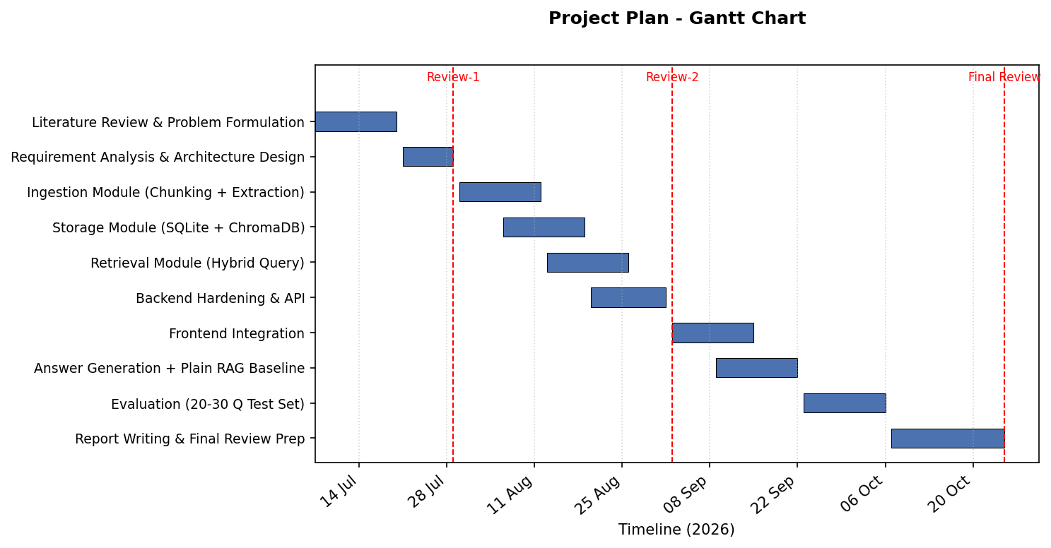
Fig. 1. Gantt chart
3. TECHNICAL SPECIFICATION
3.1 Requirements
3.1.1 Functional
• Document ingestion: upload and validate text files (rejects non-UTF8, oversized, or empty files) via POST /ingest.
• Token-based chunking with sliding-window overlap on ingested documents.
• Entity/relation extraction per chunk using a local LLM (Ollama), constrained to fixed-schema JSON output, with coreference resolution so pronouns resolve to named entities.
• Duplicate detection via content hashing before storage.
• Dual storage: graph relationships and document references in SQLite; embeddings in ChromaDB, kept in sync via atomic transactions with rollback on failure.
• Semantic query endpoint (GET /query): vector similarity search combined with multi-entity, breadth-first graph traversal up to four hops deep (toggle via an enable_graph flag).
• Answer generation (GET/POST /answer, and inline in /query): synthesizes a grounded natural-language answer from the retrieved chunks and graph edges using the local LLM.
• Graph inspection endpoints (GET /graph/stats, GET /graph/all) reporting node and edge counts and the full graph for visualization.
• Database reset endpoint (GET /reset) with confirmation parameter, for controlled testing.
• Frontend: single-page app for uploading documents, submitting questions, toggling graph traversal, viewing the generated answer, and visualizing matched chunks alongside an interactive graph of entity connections.
3.1.2 Non-Functional
• Performance: chunk ingestion and query retrieval should complete within a few seconds on consumer hardware for typical document sizes.
• Privacy: no document content or query text should leave the local device at any point.
• Scalability: the storage layer should support incremental growth of the graph across many documents without full reprocessing.
• Reliability: ingestion should be transactional, rolling back cleanly on failure rather than leaving partial graph state.
• Usability: the frontend should let a non-technical user upload a document and ask a question without configuration.
• Maintainability: the codebase should be organized into clearly separated modules (ingestion, storage, retrieval, generation, API) so individual components can be modified independently.
• Portability: the entire system should run from a single local database file plus the Ollama runtime, with no cloud service dependency.
3.2 Feasibility Study
3.2.1 Technical Feasibility
All core components required for this project, small on-device language models served through Ollama, SQLite for structured storage, ChromaDB for vector similarity search, and FastAPI for the backend, are mature, actively maintained, open-source tools that run on standard consumer hardware. Both team members have prior experience with Python and REST API development, and the project does not require training any model from scratch, only prompting an existing small model for constrained JSON extraction. The main technical risk, the reliability of a 1-3B parameter model at structured extraction, has already been partially validated during ingestion testing and is manageable through the retry and validation logic already implemented.
3.2.2 Economic Feasibility
The project has no recurring cost. All software used (Ollama, SQLite, ChromaDB, FastAPI, and the small language models themselves) is free and open-source, and inference runs on the developers' own laptops rather than a paid cloud API. This is in direct contrast to cloud-based GraphRAG systems, whose ingestion cost scales with the number of large-LLM calls made per document. The only cost is the one-time hardware already available to the team, making the project economically feasible for continued use even after submission.
3.2.3 Social Feasibility
Because the system runs entirely offline and does not require any documents to be uploaded to a third party, it is directly usable by individuals and organizations with privacy or compliance constraints that would otherwise prevent them from using a cloud-based RAG tool. The frontend is designed to require no technical setup beyond running the application locally, so the target users, researchers, students, or small teams organizing their own notes, do not need machine learning expertise to use it. No user data is collected or transmitted, which avoids the ethical and consent concerns associated with cloud-based document processing.
3.3 System Specification
3.3.1 Hardware Specification
Processor | Quad-core CPU or better (Intel i5 / AMD Ryzen 5, 10th generation or newer recommended)
Memory (RAM) | 16 GB minimum (required to run a 1-3B parameter model locally alongside the application)
Storage | 10 GB free disk space (local database, model weights, and dependencies)
Graphics Processing Unit (GPU) | Optional; a CUDA-capable GPU or Apple Silicon accelerates local inference but is not required
Monitor | Standard display, 1366x768 or higher, for the web frontend

3.3.2 Software Specification
Operating System | Windows 10/11, macOS, or Linux
Programming Language | Python 3.11+
Development Environment | Visual Studio Code; uv (package/dependency manager)
Libraries and Frameworks | FastAPI, Ollama (qwen2.5-coder:7b, snowflake-arctic-embed2:568m), tiktoken, Pydantic
Database | SQLite (graph edges and document metadata), ChromaDB (vector embeddings)
Security Tools | Input validation and content-hash based duplicate detection built into the ingestion pipeline (file type, size, and encoding checks)
4. DESIGN APPROACH AND DETAILS
4.1 System Architecture
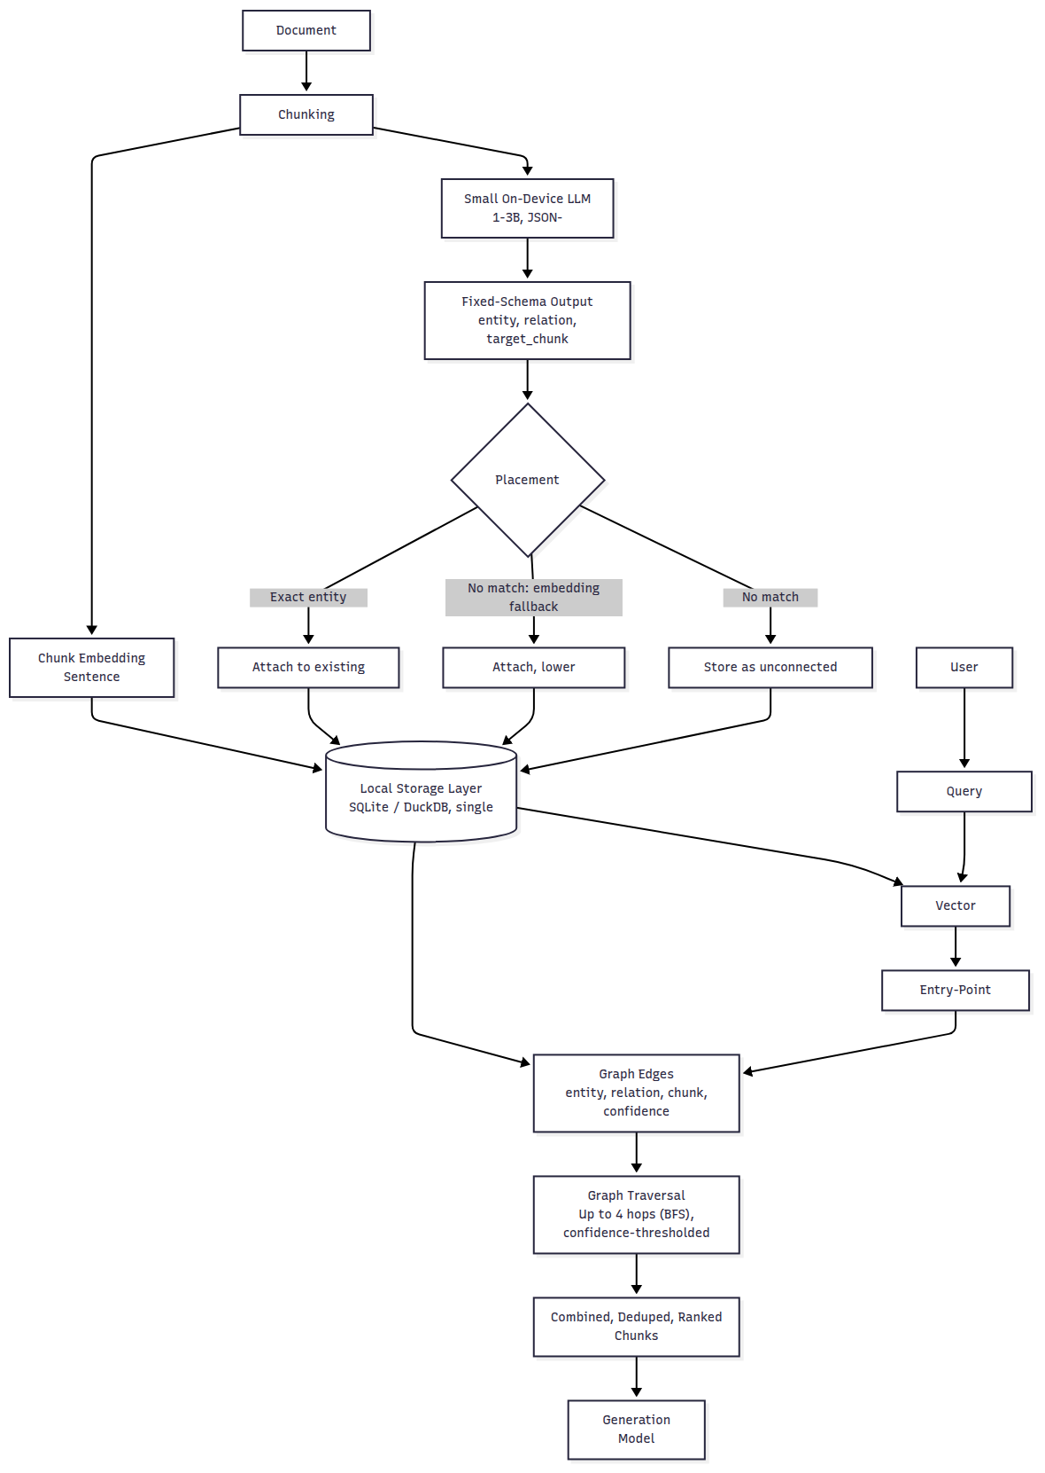
Fig. 2. System Architecture
Figure 2 shows the system architecture. A document is chunked and passed through two parallel paths: a sentence-transformer embedding model, and a small on-device LLM that performs fixed-schema entity/relation extraction. The placement logic then attaches each extracted relation to the existing graph using exact entity matching, an embedding-similarity fallback, or, if neither matches, stores the chunk as an unconnected island. Both the embeddings and the graph edges are written to a single local storage layer (SQLite for graph edges and document metadata, ChromaDB for the vector index). At query time, a user query is embedded and matched against the vector index to find entry-point chunks; a breadth-first graph traversal, up to four hops deep and confidence-thresholded, expands outward from these entry points, and the combined, deduplicated, and ranked set of chunks is passed to a generation model to produce the final answer.
4.2 Design
4.2.1 Data Flow Diagram
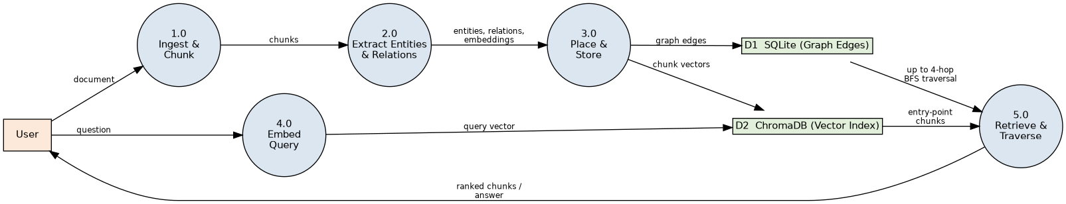
Fig. 3. Data Flow Diagram (Level 1)
The DFD traces two flows through the system. The ingestion flow (top) takes a document from the user through chunking and entity/relation extraction, writing graph edges to SQLite (D1) and chunk vectors to ChromaDB (D2). The query flow (bottom) embeds a user question, uses the vector index to find entry-point chunks, traverses up to four graph hops outward from those points via breadth-first search, and returns the combined ranked chunks (or generated answer) back to the user.
4.2.2 Use Case Diagram
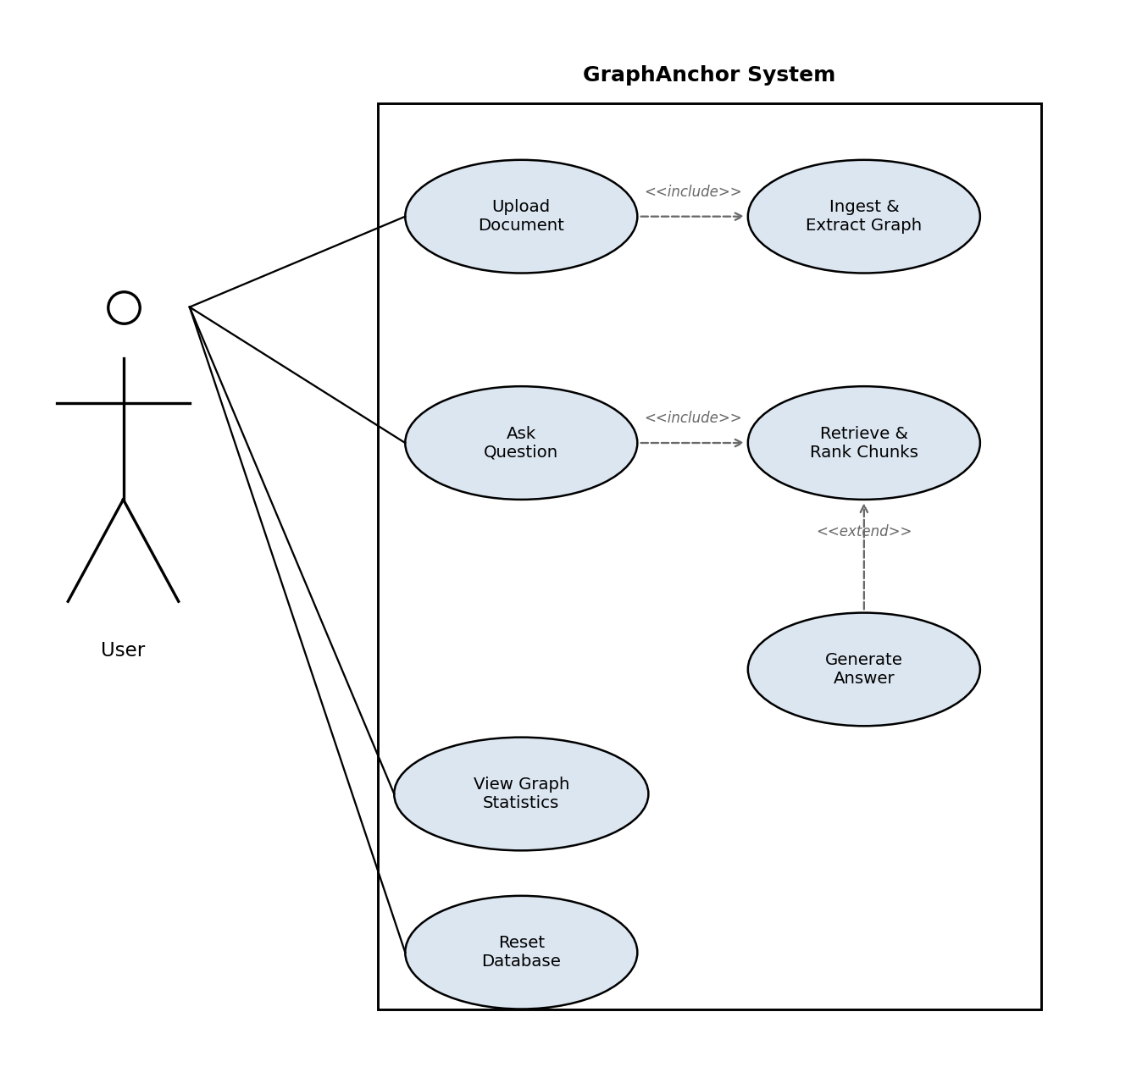
Fig. 4. Use Case Diagram
The user directly invokes four use cases: uploading a document, asking a question, viewing graph statistics, and resetting the database. Uploading a document includes the system-internal ingest and graph-extraction use case; asking a question includes retrieving and ranking chunks, which extends into generating a grounded natural-language answer from the retrieved context.
5. REFERENCES
Weblinks
[1] Databricks, "RAG Workflow Guide," Databricks Blog, 2025.
[2] S. Voora, "Retrieval-Augmented Generation (RAG) Series Part 6: Query Routing," Medium, 2025.
[3] "Contextual Retrieval: The Preprocessing Step That Makes RAG Actually Work," Towards AI, 2024.
[4] P. Pathak, "Top Vector Databases for AI Agents: A 2026 Developer Guide," DEV Community, 2026.
[5] Atlan, "Agentic AI Memory vs Vector Database," Atlan Knowledge Base, 2026.
Journals / Preprints
[1] Y. Gao, Y. Xiong, X. Gao, K. Jia, J. Pan, Y. Bi, Y. Dai, J. Sun, M. Wang, and H. Wang, "Retrieval-Augmented Generation for Large Language Models: A Survey," arXiv:2312.10997, 2023.
[2] S. Wu, Y. Xiong, Y. Cui, H. Wu, C. Chen, Y. Yuan, L. Huang, X. Liu, T.-W. Kuo, N. Guan, and C. J. Xue, "Retrieval-Augmented Generation for Natural Language Processing: A Survey," arXiv:2407.13193, 2024.
[3] Z. Jiang, P. Wu, X. Yuan, W. Fan, and Q. Li, "QA-Dragon: Query-Aware Dynamic RAG System for Knowledge-Intensive Visual Question Answering," arXiv:2508.05197, 2025.
[4] S. Agarwal, S. Sundaresan, S. Mitra, D. Mahapatra, A. Gupta, R. Sharma, N. J. Kapu, T. Yu, and S. Saini, "Cache-Craft: Managing Chunk-Caches for Efficient Retrieval-Augmented Generation," arXiv:2502.15734, 2025.
[5] B. Yang, Q. Leng, J. Zeng, and Z. Wu, "CacheClip: Accelerating RAG with Effective KV Cache Reuse," arXiv:2510.10129, 2025.
[6] E. Lumer, P. Honaganahalli Basavaraju, M. Mason, J. A. Burke, et al., "Graph RAG-Tool Fusion," arXiv:2502.07223, 2025.
[7] X. Yue, G. Qu, and L. Gan, "LiteSemRAG: Lightweight LLM-Free Semantic-Aware Graph Retrieval for Robust RAG," arXiv:2604.16350, 2026.
[8] Y. Wu, P. Liang, Y. Xiang, M. Yuan, J. Liu, J. Yang, X. Li, and W. Yan, "Tiny-Critic RAG: Empowering Agentic Fallback with Parameter-Efficient Small Language Models," arXiv:2603.00846, 2026.
[9] D. Edge, H. Trinh, N. Cheng, J. Bradley, A. Chao, A. Mody, S. Truitt, D. Metropolitansky, R. O. Ness, and J. Larson, "From Local to Global: A Graph RAG Approach to Query-Focused Summarization," Microsoft Research, arXiv:2404.16130, 2024.
[10] B. Peng, Y. Zhu, Y. Liu, X. Bo, H. Shi, C. Hong, Y. Zhang, and S. Tang, "Graph Retrieval-Augmented Generation: A Survey," arXiv:2408.08921, 2024.
[11] J. Sun, C. Xu, L. Tang, S. Wang, C. Lin, Y. Gong, L. M. Ni, H.-Y. Shum, and J. Guo, "Think-on-Graph: Deep and Responsible Reasoning of Large Language Models with Knowledge Graphs," arXiv:2307.07697, 2023.
[12] S. Ji, S. Pan, E. Cambria, P. Marttinen, and P. S. Yu, "A Comprehensive Survey on Knowledge Graphs: Representation Learning, Acquisition, and Applications," IEEE Trans. Neural Netw. Learn. Syst., arXiv:2002.00388, 2021.
[13] A. Hogan, E. Blomqvist, M. Cochez, C. d'Amato, et al., "Knowledge Graphs," ACM Computing Surveys, arXiv:2003.02320, 2021.
[14] W. Shi, S. Min, M. Yasunaga, M. Seo, R. James, M. Lewis, L. Zettlemoyer, and W. Yih, "REPLUG: Retrieval-Augmented Black-Box Language Models," arXiv:2301.12652, 2023.
[15] P. Sarthi, S. Abdullah, A. Tuli, S. Khanna, A. Goldie, and C. D. Manning, "RAPTOR: Recursive Abstractive Processing for Tree-Organized Retrieval," arXiv:2401.18059, 2024.
[16] J. Johnson, M. Douze, and H. Jegou, "Billion-Scale Similarity Search with GPUs," arXiv:1702.08734, 2017.
[17] Y. A. Malkov and D. A. Yashunin, "Efficient and Robust Approximate Nearest Neighbor Search Using Hierarchical Navigable Small World Graphs," arXiv:1603.09320, 2016.
[18] H. Touvron, L. Martin, K. Stone, et al., "Llama 2: Open Foundation and Fine-Tuned Chat Models," arXiv:2307.09288, 2023.
[19] A. Grattafiori, A. Dubey, A. Jauhri, et al. (Meta AI), "The Llama 3 Herd of Models," arXiv:2407.21783, 2024.
[20] A. Q. Jiang, A. Sablayrolles, A. Mensch, et al., "Mistral 7B," arXiv:2310.06825, 2023.
[21] H. Trivedi, N. Balasubramanian, T. Khot, and A. Sabharwal, "MuSiQue: Multihop Questions via Single-Hop Question Composition," Trans. Assoc. Comput. Linguist. (TACL), arXiv:2108.00573, 2022.
[22] L. Xiong, C. Xiong, Y. Li, K.-F. Tang, J. Liu, P. Bennett, J. Ahmed, and A. Overwijk, "Approximate Nearest Neighbor Negative Contrastive Learning for Dense Text Retrieval," arXiv:2007.00808, 2020.
[23] R. Nogueira and K. Cho, "Passage Re-ranking with BERT," arXiv:1901.04085, 2019.
[24] G. Izacard, M. Caron, L. Hosseini, S. Riedel, P. Bojanowski, A. Joulin, and E. Grave, "Unsupervised Dense Information Retrieval with Contrastive Learning," arXiv:2112.09118, 2021.
Conference
[1] X. Zhu, Y. Xie, Y. Liu, Y. Li, and W. Hu, "Knowledge Graph-Guided Retrieval Augmented Generation," in Proc. NAACL, 2025, arXiv:2502.06864.
[2] P. Lewis, E. Perez, A. Piktus, F. Petroni, V. Karpukhin, N. Goyal, H. Kuttler, M. Lewis, W. Yih, T. Rocktaschel, S. Riedel, and D. Kiela, "Retrieval-Augmented Generation for Knowledge-Intensive NLP Tasks," in Proc. NeurIPS, 2020, arXiv:2005.11401.
[3] V. Karpukhin, B. Oguz, S. Min, P. Lewis, L. Wu, S. Edunov, D. Chen, and W. Yih, "Dense Passage Retrieval for Open-Domain Question Answering," in Proc. EMNLP, 2020, arXiv:2004.04906.
[4] K. Guu, K. Lee, Z. Tung, P. Pasupat, and M.-W. Chang, "REALM: Retrieval-Augmented Language Model Pre-Training," in Proc. ICML, 2020, arXiv:2002.08909.
[5] G. Izacard and E. Grave, "Leveraging Passage Retrieval with Generative Models for Open Domain Question Answering," in Proc. EACL, 2021, arXiv:2007.01282.
[6] S. Borgeaud, A. Mensch, J. Hoffmann, et al., "Improving Language Models by Retrieving from Trillions of Tokens," in Proc. ICML, 2022, arXiv:2112.04426.
[7] Z. Jiang, F. F. Xu, L. Gao, Z. Sun, Q. Liu, J. Dwivedi-Yu, Y. Yang, J. Callan, and G. Neubig, "Active Retrieval Augmented Generation," in Proc. EMNLP, 2023, arXiv:2305.06983.
[8] M. Yasunaga, H. Ren, A. Bosselut, P. Liang, and J. Leskovec, "QA-GNN: Reasoning with Language Models and Knowledge Graphs for Question Answering," in Proc. NAACL, 2021, arXiv:2104.06378.
[9] X. Zhang, A. Bosselut, M. Yasunaga, H. Ren, P. Liang, C. D. Manning, and J. Leskovec, "GreaseLM: Graph Reasoning Enhanced Language Models," in Proc. ICLR, 2022, arXiv:2201.08860.
[10] E. J. Hu, Y. Shen, P. Wallis, Z. Allen-Zhu, Y. Li, S. Wang, L. Wang, and W. Chen, "LoRA: Low-Rank Adaptation of Large Language Models," in Proc. ICLR, 2022, arXiv:2106.09685.
[11] A. Vaswani, N. Shazeer, N. Parmar, J. Uszkoreit, L. Jones, A. N. Gomez, L. Kaiser, and I. Polosukhin, "Attention Is All You Need," in Proc. NeurIPS, 2017, arXiv:1706.03762.
[12] J. Devlin, M.-W. Chang, K. Lee, and K. Toutanova, "BERT: Pre-training of Deep Bidirectional Transformers for Language Understanding," in Proc. NAACL, 2019, arXiv:1810.04805.
[13] N. Reimers and I. Gurevych, "Sentence-BERT: Sentence Embeddings using Siamese BERT-Networks," in Proc. EMNLP, 2019, arXiv:1908.10084.
[14] Z. Yang, P. Qi, S. Zhang, Y. Bengio, W. W. Cohen, R. Salakhutdinov, and C. D. Manning, "HotpotQA: A Dataset for Diverse, Explainable Multi-hop Question Answering," in Proc. EMNLP, 2018, arXiv:1809.09600.
[15] F. Petroni, A. Piktus, A. Fan, P. Lewis, et al., "KILT: A Benchmark for Knowledge Intensive Language Tasks," in Proc. NAACL, 2021, arXiv:2009.02252.
[16] Z. Zhong and D. Chen, "A Frustratingly Easy Approach for Entity and Relation Extraction," in Proc. NAACL, 2021, arXiv:2010.12812.
[17] O. Khattab and M. Zaharia, "ColBERT: Efficient and Effective Passage Search via Contextualized Late Interaction over BERT," in Proc. SIGIR, 2020, arXiv:2004.12832.
[18] K. Santhanam, O. Khattab, J. Saad-Falcon, C. Potts, and M. Zaharia, "ColBERTv2: Effective and Efficient Retrieval via Lightweight Late Interaction," in Proc. NAACL, 2022, arXiv:2112.01488.
[19] D. Chen, A. Fisch, J. Weston, and A. Bordes, "Reading Wikipedia to Answer Open-Domain Questions," in Proc. ACL, 2017, arXiv:1704.00051.
[20] K. Lee, L. He, M. Lewis, and L. Zettlemoyer, "End-to-End Neural Coreference Resolution," in Proc. EMNLP, 2017, arXiv:1707.07045.
[21] K. Clark and C. D. Manning, "Improving Coreference Resolution by Learning Entity-Level Distributed Representations," in Proc. ACL, 2016, arXiv:1606.01323.

